

STOCK PRICE PREDICTION
Proj-220064-Team-1-phase-1-phase-2
STOCK PRICE PREDICTION
- Introduction

- Stock market is an aggregation stockbrokers and traders who can
buy and sell shares of stocks.
- Stock data is non-stationary, chaotic, random and depends on
several technical parameters.
- Since statistical approaches are linear in nature, it hampere
prediction performances in case of sudden rise or fall of
prices of or fall of stock
- In modern days of artificial intelligence, machine learning plays a
important role in time series predictions.

- Objectives

- To predict stock prices using both statistical and machine learning
approaches.
- To make comparison between statistical and machine learning
approach predictions.
- To find a better approach, which predicts prices of the stocks more
accurately

- Linear Regression

- Linear regression is a type of supervised machine learning algorithm
that computes the linear relationship between a dependent
variable and one or more independent features
- The goal of the algorithm is to find the best linear equation that can
predict the value of the dependent variable based on the
independent variable.

- Feature Selection

- For time series prediction, selection of features is an important task.
- Because selection of worst features can direct the prediction to a wrong way.
- In this system, three features have been selected.
i. The opening price
ii. The highest price
iii. The lowest price.
- Program

plt.figure(figsize=(15,5))

plt.plot(df['Close'])

plt.title('Tesla Close price.', fontsize=15)

plt.ylabel('Price in dollars.')
plt.show()

Output:

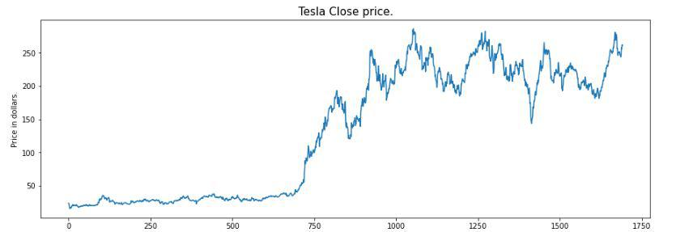

.plt.subplots(figsize=(20,10))

for i, col in enumerate(features):

plt.subplot(2,3,i+1)

sb.boxplot(df[col])
plt.show()

Output:

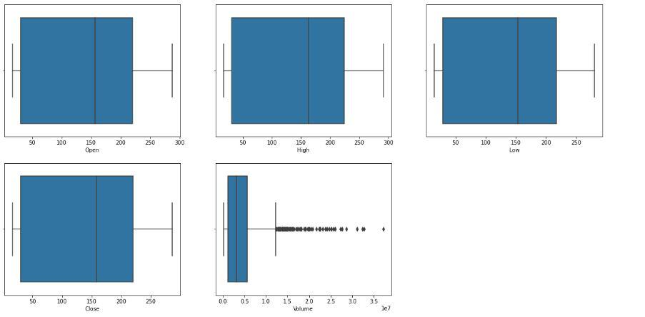

- Program

features = ['Open', 'High', 'Low', 'Close', 'Volume']

plt.subplots(figsize=(20,10))

for i, col in enumerate(features):

plt.subplot(2,3,i+1)
sb.distplot(df[col])
plt.show()

Output:
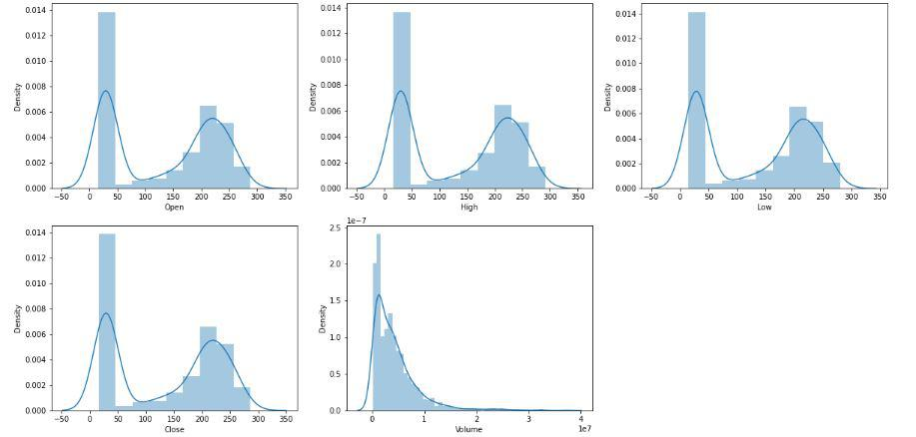

- Program

// Program to find best buying and selling days
import java.util.ArrayList;

// Solution structure
class Interval {
int buy, sell;
}

class StockBuySell {
// This function finds the buy sell schedule for maximum
// profit
void stockBuySell(int price[], int n)
{
// Prices must be given for at least two days
if (n == 1)
return;

int count = 0;

// solution array
ArrayList<Interval> sol = new ArrayList<Interval>();

// Traverse through given price array
int i = 0;
while (i < n - 1) {
// Find Local Minima. Note that the limit is
// (n-2) as we are comparing present element to
// the next element.
while ((i < n - 1)
&& (price[i + 1] <= price[i]))
i++;

// If we reached the end, break as no further
// solution possible
if (i == n - 1)
break;

Interval e = new Interval();
e.buy = i++;
// Store the index of minima

// Find Local Maxima. Note that the limit is
// (n-1) as we are comparing to previous element
while ((i < n) && (price[i] >= price[i - 1]))
i++;

// Store the index of maxima
e.sell = i - 1;
sol.add(e);

// Increment number of buy/sell
count++;
}

// print solution
if (count == 0)
System.out.println(
"There is no day when buying the stock "
+ "will make profit");
else
for (int j = 0; j < count; j++)
System.out.println(
"Buy on day: " + sol.get(j).buy
+ " "
+ "Sell on day : " + sol.get(j).sell);

return;
}

public static void main(String args[])
{
StockBuySell stock = new StockBuySell();

// stock prices on consecutive days
int price[] = { 100, 180, 260, 310, 40, 535, 695 };
int n = price.length;

// function call
stock.stockBuySell(price, n);
}
}

// This code has been contributed by Mayank Jaiswal

Output:

Buy on day: 0 Sell on day: 3
Buy on day: 4 Sell on day: 6

- The Proposed System

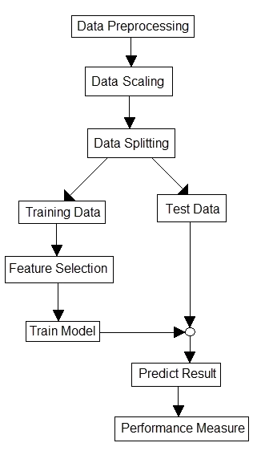

- Current Stock Price

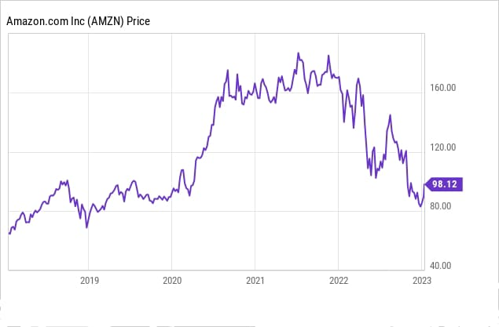

- Conclusion

- A comparative study between statistical approaches and machine learning approaches has been done in terms of prediction performances.
- Machine learning methods, especially, MLP and LSTM are found to be the most accurate to predict stock prices.

THANK YOU

